INTAKE MANIFOLD VACUUM AND AIR HOSE REPLACEMENT

Replacing all the old, crusty air and vacuum hoses under and around the intake manifold. requires removing the intake manifold.
While you've got the intake manifold off, it would be good to change the PCV valve and the knock sensors. Both are much more difficult to replace when the intake manifold is installed.

Throttle body and intake manifold removal
The intake manifold and throttle body are pretty heavy, so remove the throttle body first. The FSM suggests removing the alternator, but not absolutely necessary. Keep track of where all the hoses and bolts go as you remove parts.
1) Drain fuel from fuel rail as described in the FSM
2) Remove throttle cable and cruise control cable.
3) Remove air intake pipe and place some protection over the MAF inlet so nothing damages the MAF.
4) Disconnect all hoses attaching to the throttle body. There are several air hoses and two water hoses. The hoses are usually stuck. You may find that in almost all cases, you may be able to loosen the hoses by gently twisting the hoses on the pipe with a pair of regular pliers.
5) Disconnect TPS electrical plug.
4) Remove the bolts securing the throttle body to the intake manifold.
6) As you pull the throttle body away, disconnect the IAC electrical plug from the bottom of the throttle body.
7) Disconnect the electrical plugs on the fuel injectors, the plug on the sensor going to the PS pump, and the plug for the EGR sensor at the back left (as you face the motor) of the intake manifold.
8) Remove the fuel pressure regulator (FPR). The screws can be difficult to loosen. Be careful not to strip the screws.
9) Disconnect the EGR tube from the passenger side rear of the intake manifold.
10) Disconnect the hose going to the PCV valve. Disconnect it at the crank case.
11) Pull the vacuum line going to the brake booster. Pull it at the intake manifold.

12) Disconnect the electrical plug that goes to the aux air controller on the driver’s side of the engine under the intake manifold.
13) Remove all the bolts holding the metal fuel lines to the fuel rails. There are three sets of two bolts.
14) Disconnect the fuel lines and vapor line attaching to the intake manifold on the driver’s side of the intake manifold.
15) Disconnect the vapor lines going to the charcoal canister. Disconnect the lines at the intake manifold.
16) Disconnect the plugs between the fuel injector harness and the main wiring harness. There are two plugs. These are at the back of the engine on the passenger side.
17) Disconnect the two vacuum hoses that go from the EGR system to the metal vacuum lines at the passenger side rear of the intake manifold.
18) Remove a bolt at the passenger side rear of the engine that secures the metal fuel lines to the cylinder head.
19) Remove the bolt securing the thick metal bracket to the driver side front of the intake manifold. The bracket links the intake manifold and the AC compressor.
20) Remove the bolts securing the intake manifold to the risers. The intake manifold bolt at the driver side front of the intake manifold will be difficult to reach. If you like, you can do as the FSM suggests and move the AC compressor forward.
The intake manifold, metal fuel/air lines and the injector wiring harness will all come off as one piece. You'll have to slightly bend the metal fuel line to clear the air conditioner pipe at the driver side front of the intake manifold.
You'll probably have to reposition the injector wiring harness as you lift off the intake manifold.
Take care not to get any dirt/debris into the fuel rails on the engine or into the fuel pipes on the manifold! Any small amount of debris can and will clog fuel injectors

Replacing the hoses
The hoses are usually stuck pretty well to the metal and plastic piping. I found that in almost all cases, I was able to remove the hoses by gently twisting the hoses on the pipe with a pair of regular pliers. Gently grip the hose where it attaches to a pipe, and try gently twisting the hose. Spraying a little silicone lube would probably help. Be very careful when removing hose from the solenoids with plastic nipples. That plastic can and will break if too much force is applied. It may be necessary to slice the hose lengthwise and peel it off the nipple.
Below are two photos showing all the vacuum lines that were replaced under the manifold and on top of the engine.
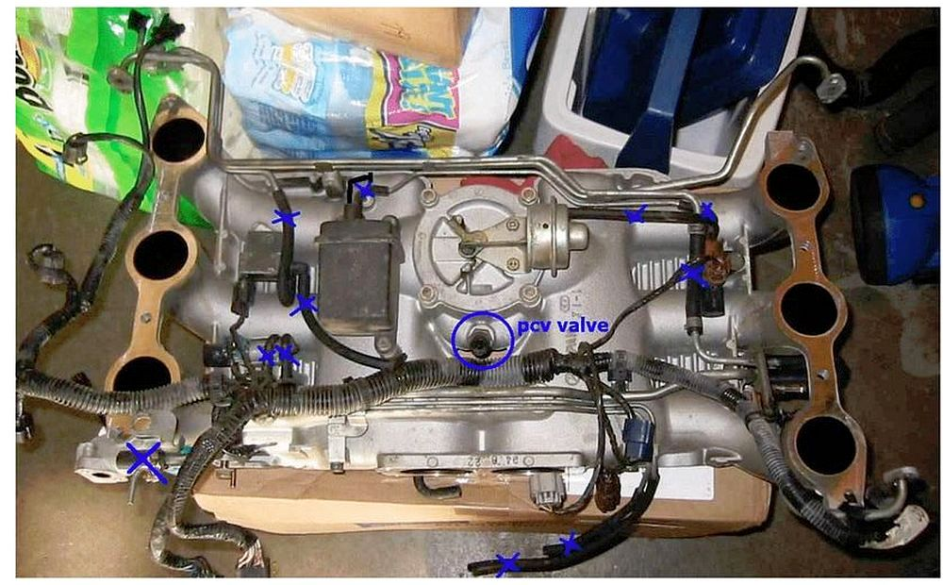
UNDERSIDE OF INTAKE MANIFOLD

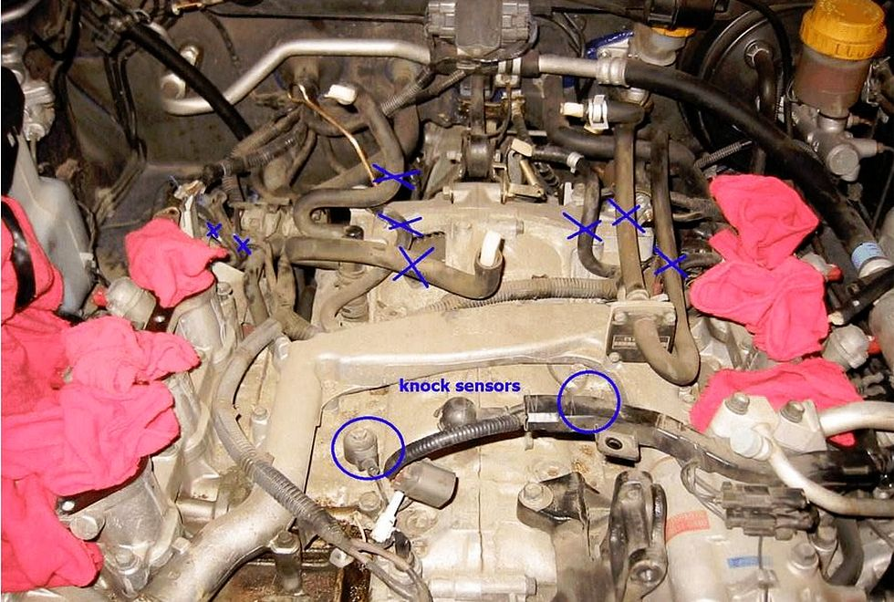

TOP OF ENGINE BLOCK

If you want, you can use non-Subaru hose to replace the 3 mm vacuum lines. It will save you quite a bit of money.
Viton rubber tubing is rated to much higher operating temperatures (400F) than standard nitrile rubber tubing (250F) sold at auto parts stores. I have listed a Viton hose supplier in the table at the end of the document.
As the end of this document, there is a list of hoses and other replaceable items with their part numbers.

Replacing other items
This would also be a good time to replace the PCV valve and the knock sensors. Both are very easy to access while the intake manifold is off, while almost impossible to reach when the intake manifold is on. Knock sensors and PCV valve are shown in the pictures below. Use teflon pipe tape when installing the new PCV valve.
Knock sensor torque value: 31 ft-lbs.
The PCV valve has pipe threads.
It would also be good to replace the fuel rail o-rings. I have listed the part number for these in the table at the end of the document.
Obtaining parts
I recommend buying your OEM Subaru parts from Annapolis Subaru. They have the best prices of any Subaru dealer. Their shipping prices are also the best.
1-888-851-5976 ask for Jackie Wetzler

Reinstallation of intake manifold
Installation is pretty much in the reverse order. Use new intake manifold and throttle body gaskets. The intake manifold gaskets have little tabs that can be bent down to hold the gasket to the intake risers. Be sure that you've installed all the hoses correctly and that all the electrical plugs have been reinstalled. After getting the manifold reinstalled and everything buttoned up, flush the fuel rails with gasoline by turning the ignition to "on" but not starting the car. Leave it at "on" for a few minutes.
